Please use Village corporate font types for the content accordingly. You may download them here:
• Freight (for headline): https://fareasthosp.egnyte.com/dl/BOhTkrtDS8/FreightBigBlack.otf_
• Gotham Book (for bodycopy): https://fareasthosp.egnyte.com/dl/hMrovOC5Rf/GothaBoo.otf_

Instructions to download the fonts:
Step 1: Click on the respective link above and download the font accordingly
Step 2: Save the file
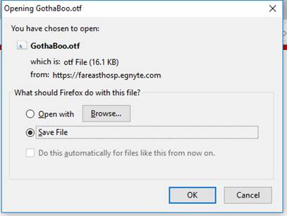
Step 3: Open the file
Step 4: Click on the ‘Install’ button to install the font on your computer
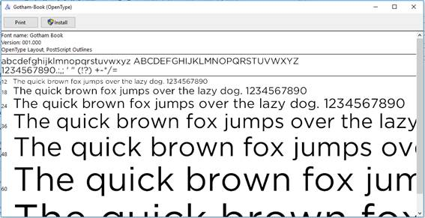

Once you have the fonts installed in your com, you will be able to view/use it in programmes like Microsoft Word/PowerPoint.

