Job Name | Meet with More Benefits
Type | Email Banner & EDM | 1st Draft Deadline | ASAP
Date | 11 Jan 2021 | FA Deadline | ASAP
Brand / Property | Village Hotel Bugis

HERO IMAGE | My proposed idea is to have a similar Zoom meeting interface with the 4 main icons and side bar. The Main icon will be changed to “New Offline Meeting” instead.  Since most companies have been doing online meetings, we want to invite them to bring their meetings offline with us.  The background don’t have to be white.  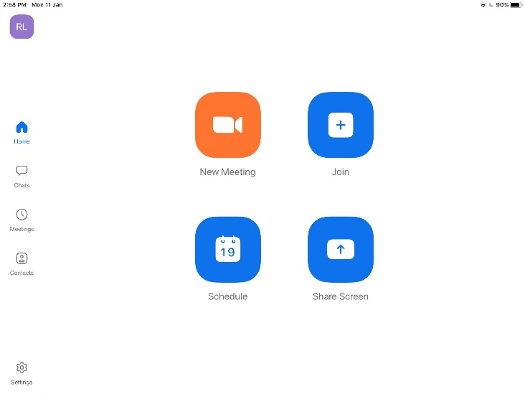
SIDE IMAGE | - Fatigue Quencher (stock image related to refreshing beverages): https://www.pexels.com/photo/sliced-orange-fruit-in-clear-drinking-glass-3323682/  - Stock image related to Assorted Pastries:  https://unsplash.com/photos/Oy4tHyQqpMU  Go ahead to propose another image related to the items if needed.
HEADLINE | -
SUBHEADER | -
BODY COPY | - EDM  Refer to below past edm for reference:  https://fareasthosp.egnyte.com/dl/JWgnnuR28I  Content:  From SGD78nett per person  - Terms and Conditions apply  - Package is valid with a minimum of 10 persons  Meet with More Benefits  No more online meetings or distractions from your pets and internet connections, but more benefits to enhance your meeting more effectively at Village Hotel Bugis.  Enjoy the following perks:  • Welcome snacks, lunch, 2 coffee breaks and a choice of Fatigue Quencher  • Use of a meeting room  • Use of audiovisual system, LCD projector and screen  • Use of one whiteboard with markers  • Use of one flipchart with papers and markers  • Free flow of freshly-brewed coffee and a selection of tea  • Writing materials  • Bottled water and mints  • Unlimited Wi-Fi access  • Carpark coupons based on 20% of the confirmed attendee  - E-banner  Refer to below image for banner guideline:  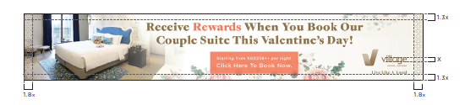  Header: Meet with More Benefits  Design: Adapt from EDM  Call To Action: Click Here for more information
CALL-TO-ACTION | -
TERMS & CONDITIONS | -
Social media | Facebook: StayVillage  Instagram: StayVillage  Website: www.VillageHotels.asia/MeetingsVHB
Logo | Village Brand Logo  https://fareasthosp.egnyte.com/dl/fzK4tJ7TU4  With our Tagline “Live Like A Local” below the logo

