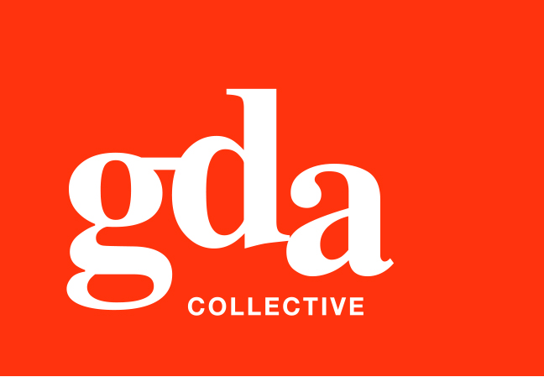
GDA Collective LLP
UEN: T20LL0431K
Ubi Ave 1 #06-09
Bizlink Centre
Singapore 408938

www.gda.sg

Dear all, Accounts-in-Charge, please see below our full banking details.

This will be our banking details to be updated with immediate effect.
Thank you.

1. Bank Name : United Overseas Bank Limited
2. Address of the Bank : 1 Farrer Park, #01-13, Connexion, Singapore 217562
3. Account Name : GDA Collective LLP
4. Account Number : 392-310-424-9
5. Name of Beneficiary : GDA Collective LLP
6. Address of Beneficiary : 59, Ubi Ave 1, Bizlink Centre, #06-09 Singapore 408938
7. ABA Number : Not required in Singapore.
8. Swift Code : UOVBSGSG
9. Bank Code No. : 7375
10. Branch Code No. : 432



