
UEN: T20LL0431K

GDA Collective LLP
Ubi Ave 1 #06-09
Bizlink Centre
Singapore 408938

www.gda.sg

Invoice
Tatsuya Japanese Restaurant
Goodwood Park Hotel date May 06, 2020
22 Scotts Road Singapore 228221 delivery order no. -
payment terms 30 days
our ref no. -
Attn: Ms Noriko job no. J/F 3195/3196/3198/3199

invoice no. INV-100002-20
description & value

Being cost for design production of Tatsuya Circuit Breaker
Promotional Material
Brief descriptions: 01. Take-away Menu
02. Weekly Special Flyer (17 Apr)
03. Weekly Special Flyer (24 Apr)
04. Omakase Bento Flyer (4 May)

Works: Design directions for initial composite SGD 150.00
Graphic design layout SGD 1,500.00
Typography: typeset SGD 450.00
Project management, co-ordination SGD 150.00
Finish artworks SGD 150.00

Grand Total SGD 2,400.00

We thank you for your business!

Please note:
Cheque/s should be crossed and made payable to GDA Collective LLP
If there should be any queries, please inform the person-in-charge and
return this bill to us within 3 days, otherwise this bill is deemed to be accepted.
Please send cheque to: 59 Ubi Avenue 1, #06-09, Bizlink Centre, Singapore 408938

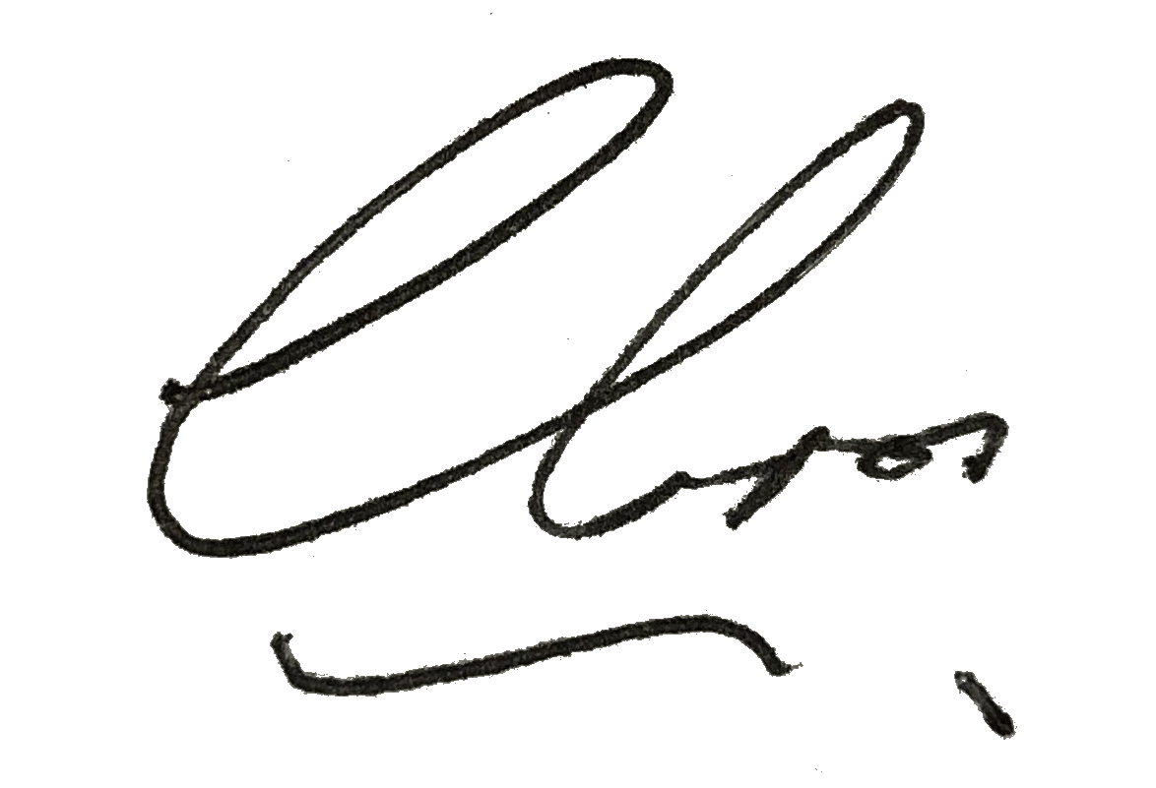
––––––––––––––––––––––––––––––––––
Authorized Signatory / GDA Collective LLP



