
UEN: T20LL0431K

GDA Collective LLP
Ubi Ave 1 #06-09
Bizlink Centre
Singapore 408938

www.gda.sg

Invoice
Tatsuya Japanese Restaurant
Goodwood Park Hotel date July 15, 2020
22 Scotts Road Singapore 228221 delivery order no. -
payment terms 30 days
our ref no. -
Attn: Mr Ronnie Chia job no. J/F 3200

invoice no. INV-100003-20
description & value

Being cost for social media posting and menu production of Tatsuya
Promotional Material for month of June 2020
Brief descriptions: 01. Take Away Menu Revision
02. A3 Menu / A3 Menu with Photos
03. Lunch / Dinner Menu Revision
04. Facebook postings (see attached for postings)

Works: Production Fee SGD 1,300.00

Grand Total SGD 1,300.00

We thank you for your business!

Please note:
Cheque/s should be crossed and made payable to GDA Collective LLP
If there should be any queries, please inform the person-in-charge and
return this bill to us within 3 days, otherwise this bill is deemed to be accepted.
Please send cheque to: 59 Ubi Avenue 1, #06-09, Bizlink Centre, Singapore 408938

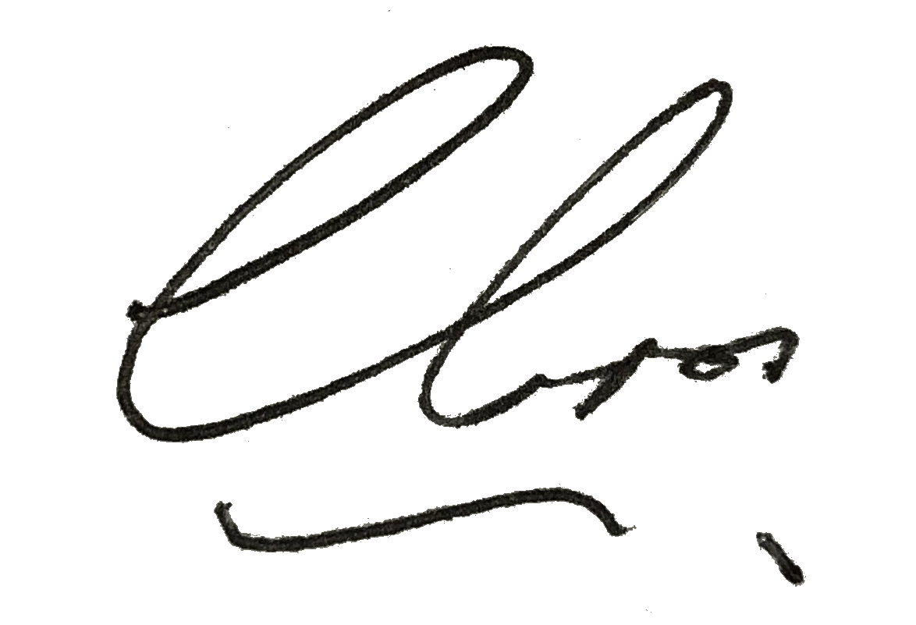
––––––––––––––––––––––––––––––––––
Authorized Signatory / GDA Collective LLP



