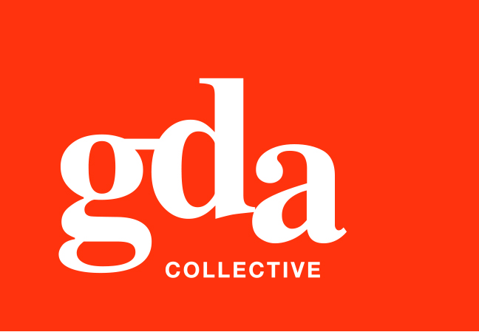
UEN: T20LL0431K

GDA Collective LLP
Ubi Ave 1 #06-09
Bizlink Centre
Singapore 408938

www.gda.sg

Invoice

HSBC Institutional Trust Services (Singapore) Limited date August 12, 2020
(in its capacity as Trustee of Victory SR Trust) delivery order no. -
payment terms 30 days
our ref no. -
Attn: Angela Lau job no. J/F 3201

invoice no. INV-100004-20
description & value

Being cost for lyf Funan Programmatic Banners production
Specifications: 01. To edit content for lyf Funan Programmatic Banners for 3 sizes
02. To output in HTML format

Works: Production Fee SGD 700.00

Grand Total SGD 700.00

We thank you for your business!

Please note:
Cheque/s should be crossed and made payable to GDA Collective LLP
If there should be any queries, please inform the person-in-charge and
return this bill to us within 3 days, otherwise this bill is deemed to be accepted.
Please send cheque to: 59 Ubi Avenue 1, #06-09, Bizlink Centre, Singapore 408938

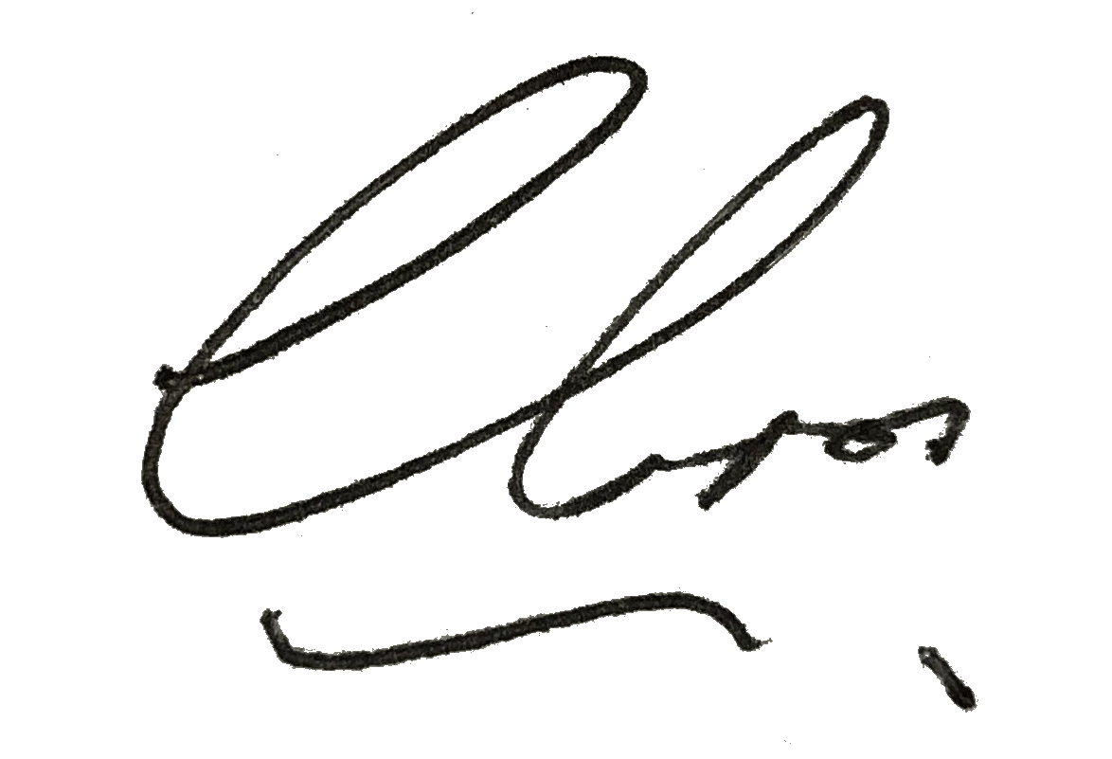
––––––––––––––––––––––––––––––––––
Authorized Signatory / GDA Collective LLP



