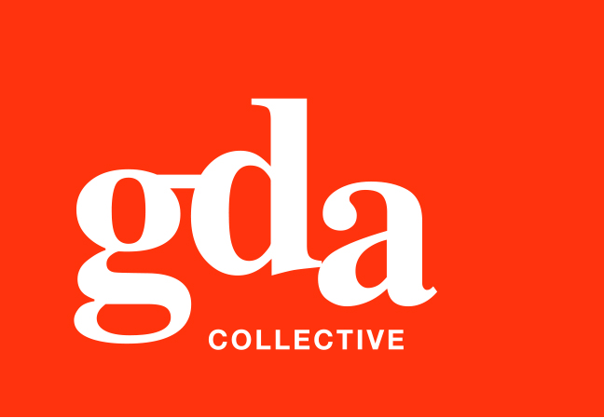
UEN: T20LL0431K

GDA Collective LLP
59 Ubi Ave 1 #06-09
Bizlink Centre
Singapore 408938

www.gda.sg

Invoice
Tatsuya Japanese Restaurant
Goodwood Park Hotel date September 30, 2020
22 Scotts Road Singapore 228221 delivery order no. -
payment terms 30 days
our ref no. -
Attn: Ms Noriko job no. J/F 3203

invoice no. INV-100006-20
description & value

Being cost for photoshoot for Tatsuya Monthly Promotional Menu

Works: Photoshoot for 6 food items – 25 August 2020 SGD 550.00
Photoshoot for 6 food items – 15 September 2020 SGD 550.00
FB and IG Banner – Design and layout fee SGD 150.00
Project management with Flame Comms – Cargo Day Photoshoot (2 days) SGD 250.00

Grand Total SGD 1,500.00

We thank you for your business!

Please note:
Cheque/s should be crossed and made payable to GDA Collective LLP
If there should be any queries, please inform the person-in-charge and
return this bill to us within 3 days, otherwise this bill is deemed to be accepted.
Please send cheque to: 59 Ubi Avenue 1, #06-09, Bizlink Centre, Singapore 408938

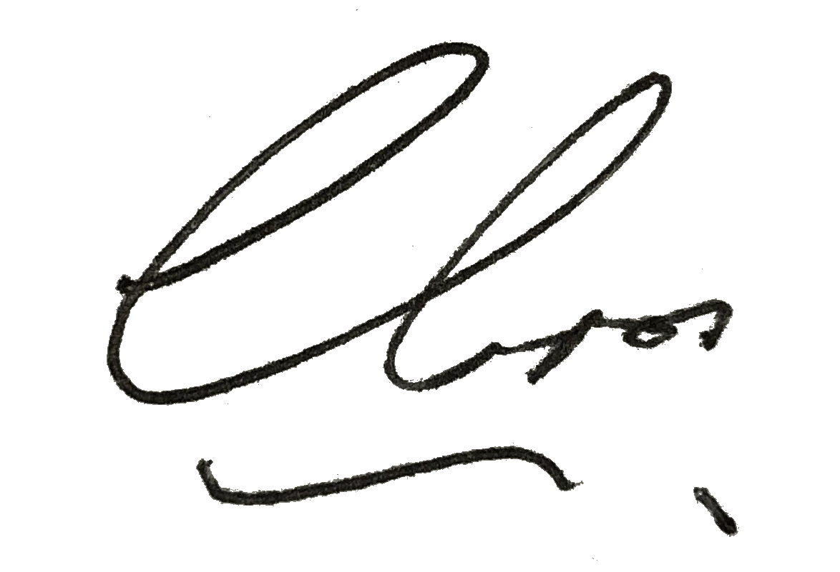
––––––––––––––––––––––––––––––––––
Authorized Signatory / GDA Collective LLP



