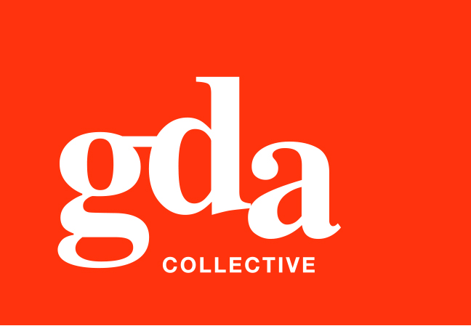
UEN: T20LL0431K

GDA Collective LLP
59 Ubi Ave 1 #06-09
Bizlink Centre
Singapore 408938

www.gda.sg

Invoice
Mizume Japanese Dining Concept Pte Ltd
41 Hongkong Street, #01-01 date October 31, 2020
Singapore 059680 delivery order no. -
payment terms 30 days
our ref no. -
Attn: Ms Lily Ham job no. J/F 3206

invoice no. INV-100009-20
description & value

Being cost for Mizume Restaurant Full Brand Creatives and Social Media Mkting Mgt

Works: 1. Logo and Brand Creation
2. Stationery Development and Design
3. Photography – Location, food and profile
4. Social Media Mkting on FB & IG – Development, creatives, copywriting, mgt
5. Menu Design and backend update support SGD 3,000.00

Grand Total SGD 3,000.00

We thank you for your business!

Please note:
Cheque/s should be crossed and made payable to GDA Collective LLP
If there should be any queries, please inform the person-in-charge and
return this bill to us within 3 days, otherwise this bill is deemed to be accepted.
Please send cheque to: 59 Ubi Avenue 1, #06-09, Bizlink Centre, Singapore 408938

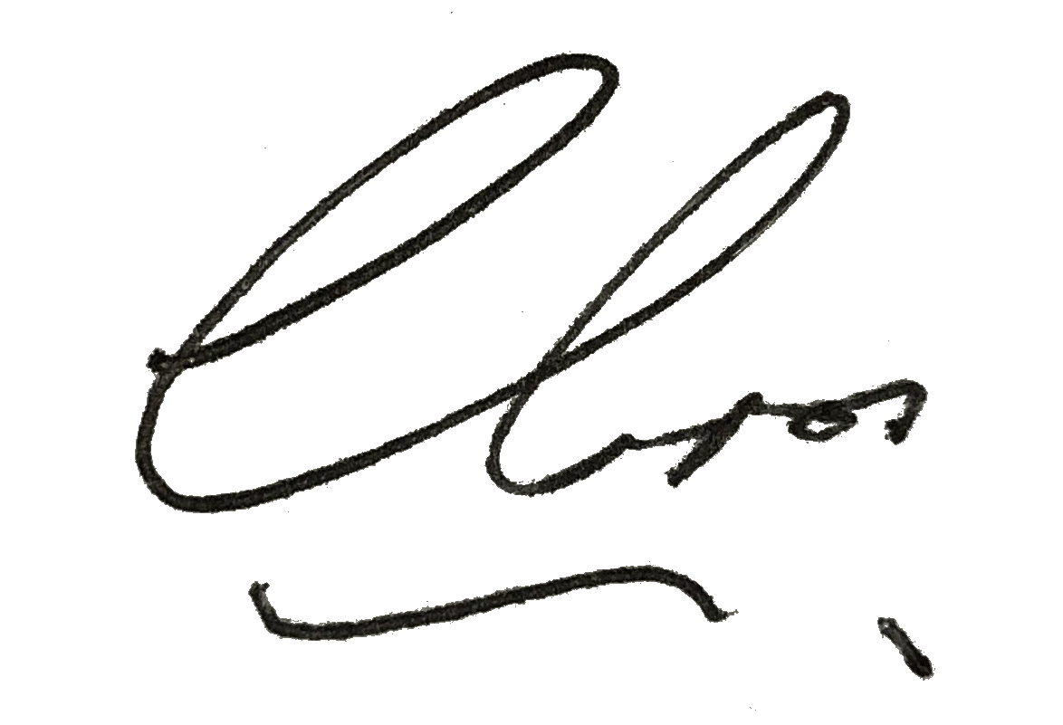
––––––––––––––––––––––––––––––––––
Authorized Signatory / GDA Collective LLP



