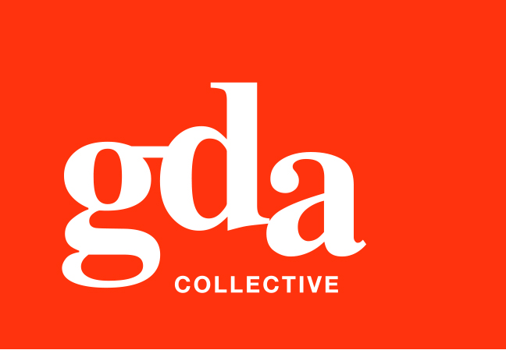
UEN: T20LL0431K

GDA Collective LLP
59 Ubi Ave 1 #06-09
Bizlink Centre
Singapore 408938

www.gda.sg

Invoice
Ascott International Management Pte Ltd
Attn: Angela Lau date November 18, 2020
delivery order no. -
payment terms 30 days
our ref no. -
job no. J/F 3207

invoice no. INV-100010-20
description & value

Being cost for Ascott Programmatic Banners production
Specifications: 01. To edit content for Ascott Programmatic Banners for 4 sizes
02. To output in HTML format

Sizes: 01. 728 x 90 px x 4 frames (English)
02. 160 x 600 px x 4 frames (English)
03. 300 x 250 px x 4 frames (English)
04. 300 x 600 px x 4 frames (English)

Works: Production Fee SGD 1,050.00

Grand Total SGD 1,050.00

We thank you for your business!

Please note:
Cheque/s should be crossed and made payable to GDA Collective LLP
If there should be any queries, please inform the person-in-charge and
return this bill to us within 3 days, otherwise this bill is deemed to be accepted.
Please send cheque to: 59 Ubi Avenue 1, #06-09, Bizlink Centre, Singapore 408938

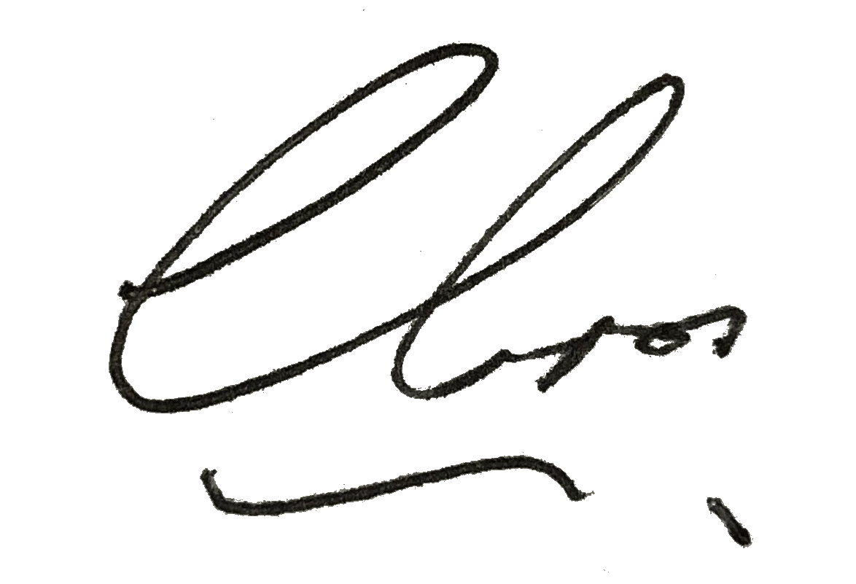
––––––––––––––––––––––––––––––––––
Authorized Signatory / GDA Collective LLP



