
UEN: T20LL0431K

GDA Collective LLP
59 Ubi Ave 1 #06-09
Bizlink Centre
Singapore 408938

www.gda.sg

Invoice
Tatsuya Japanese Restaurant
Goodwood Park Hotel date November 25, 2020
22 Scotts Road Singapore 228221 delivery order no. -
payment terms 30 days
our ref no. -
Attn: Ms Noriko job no. J/F 3209

invoice no. INV-100012-20
description & value

Being cost for photoshoot for Tatsuya Monthly Promotional Menu

Works: Photoshoot for 6 food items – 27 October 2020 SGD 550.00
Photoshoot for 6 food items – 12 November 2020 SGD 550.00

Grand Total SGD 1,100.00

We thank you for your business!

Please note:
Cheque/s should be crossed and made payable to GDA Collective LLP
If there should be any queries, please inform the person-in-charge and
return this bill to us within 3 days, otherwise this bill is deemed to be accepted.
Please send cheque to: 59 Ubi Avenue 1, #06-09, Bizlink Centre, Singapore 408938

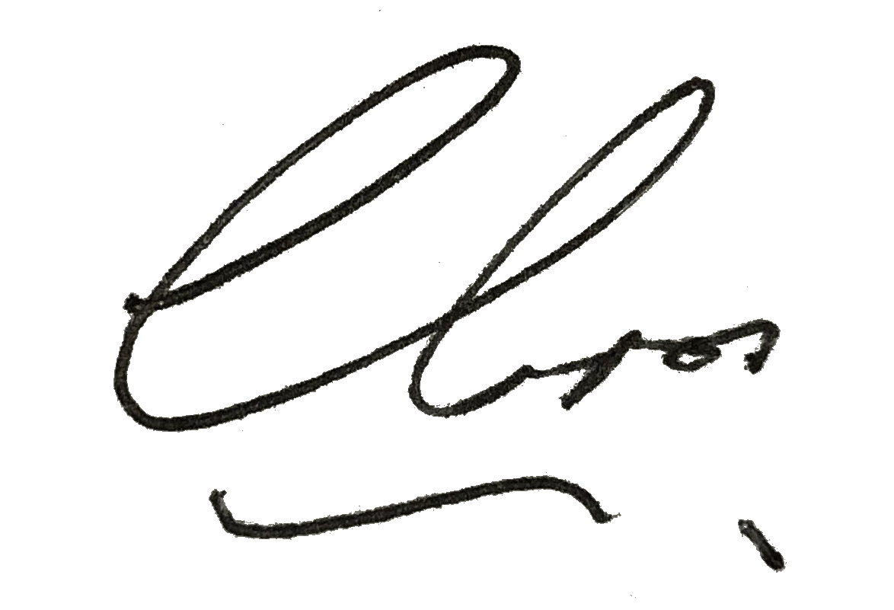
––––––––––––––––––––––––––––––––––
Authorized Signatory / GDA Collective LLP



