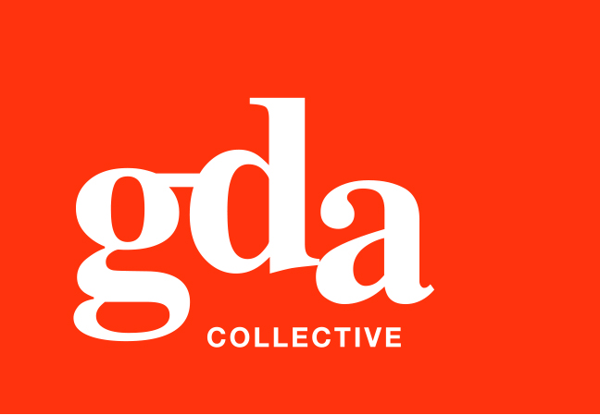
UEN: T20LL0431K

GDA Collective LLP
59 Ubi Ave 1 #06-09
Bizlink Centre
Singapore 408938

www.gda.sg

Invoice
Mizume Japanese Dining Concept Pte Ltd
41 Hongkong Street, #01-01 date December 3, 2020
Singapore 059680 delivery order no. -
payment terms 30 days
our ref no. -
Attn: Ms Lily Ham job no. J/F 3210

invoice no. INV-100013-20
description & value

Being cost for Mizume Restaurant Social Media Mkting Mgt for November 2020

Works: 1. Social Media Mkting on FB & IG
– Creatives, photography, copywriting and mgt
2. Menu revision and update (FOC) SGD 1,500.00

Grand Total SGD 1,500.00

We thank you for your business!

Please note:
Cheque/s should be crossed and made payable to GDA Collective LLP
If there should be any queries, please inform the person-in-charge and
return this bill to us within 3 days, otherwise this bill is deemed to be accepted.
Please send cheque to: 59 Ubi Avenue 1, #06-09, Bizlink Centre, Singapore 408938

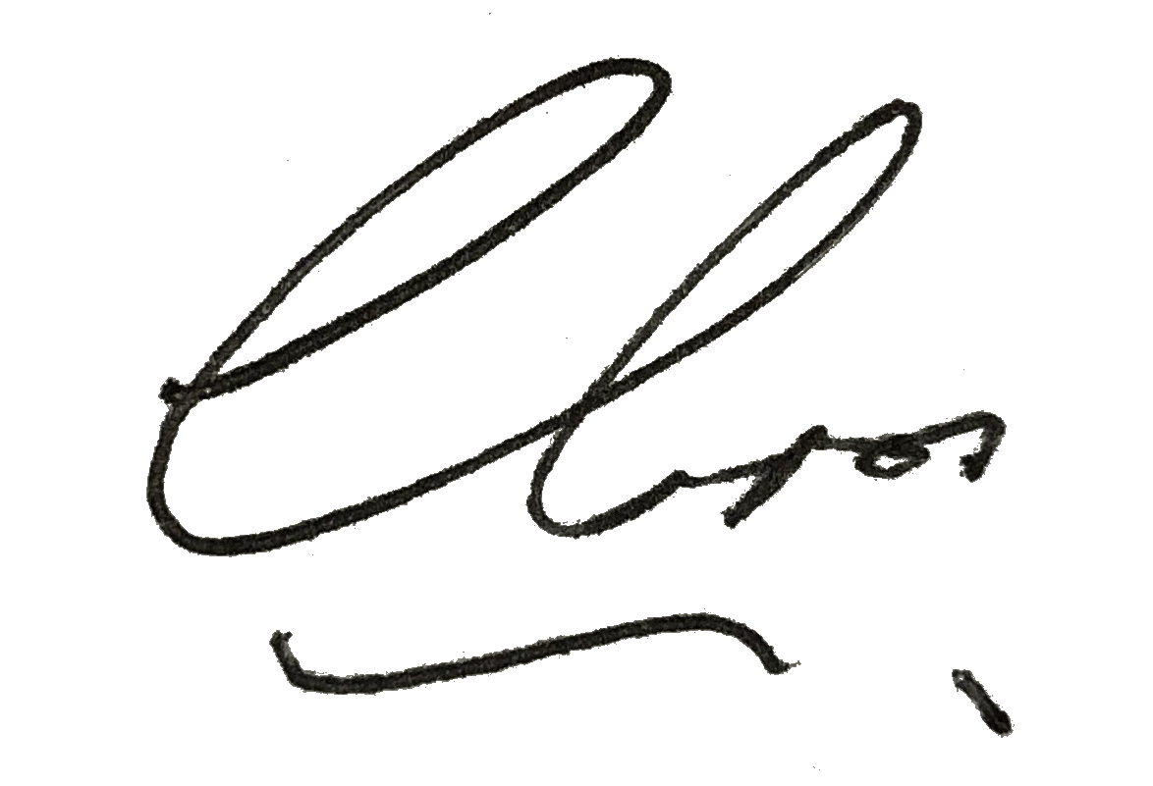
––––––––––––––––––––––––––––––––––
Authorized Signatory / GDA Collective LLP



