
UEN: T20LL0431K

GDA Collective LLP
59 Ubi Ave 1 #06-09
Bizlink Centre
Singapore 408938

www.gda.sg

Invoice
Fraser Suites Hanoi / Syrena Joint Stock Company
51 Xuan Dieu Street, Quang An Ward date January 17, 2021
Tay Ho District, Hanoi, Vietnam delivery order no. -
payment terms 30 days
our ref no. -
Attn: Ms Ng Wei Lin job no. J/F 3213

invoice no. INV-100016-21
description & value

Being cost for design fee for Fraser Suites Hanoi Fact Sheet

Specifications: Size: A4
Extent: 4pp
Colour: 4C x 4C

Design Fee SGD 780.00

Grand Total SGD 780.00

We thank you for your business!

Please note:
Cheque/s should be crossed and made payable to GDA Collective LLP
If there should be any queries, please inform the person-in-charge and
return this bill to us within 3 days, otherwise this bill is deemed to be accepted.
Please send cheque to: 59 Ubi Avenue 1, #06-09, Bizlink Centre, Singapore 408938

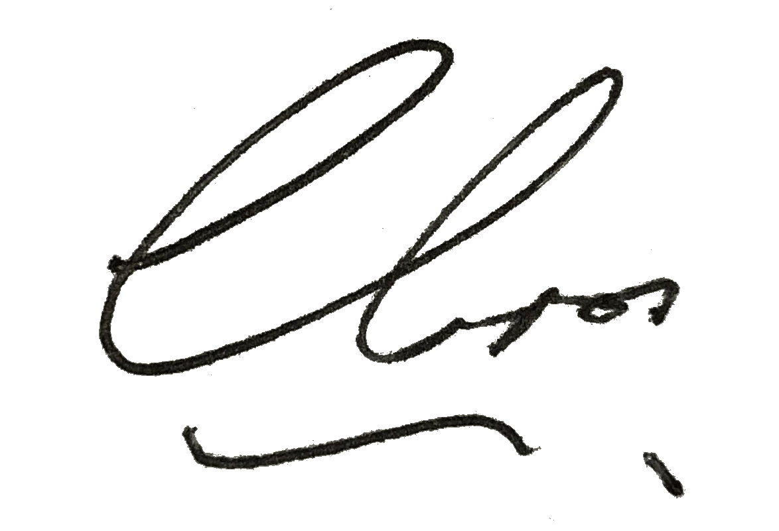
––––––––––––––––––––––––––––––––––
Authorized Signatory / GDA Collective LLP

