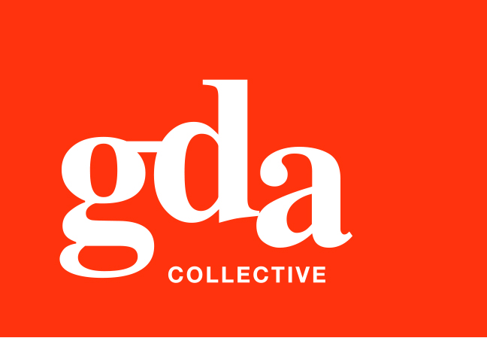
UEN: T20LL0431K

GDA Collective LLP
59 Ubi Ave 1 #06-09
Bizlink Centre
Singapore 408938

www.gda.sg

Invoice
Village Residence Hougang
Serene Lane Pte Ltd date July 18, 2021
1 Hougang Street 91 delivery order no. -
Singapore 538692 payment terms 30 days
our ref no. -
Attn: Ms Suraiyah Binti Zainal – Residence Manager job no. -

invoice no. INV-100070-21
description & value

Being cost for design fee for Village Residence Hougang

Design Fee SGD 300.00

Grand Total SGD 300.00

We thank you for your business!

Please note:
Cheque/s should be crossed and made payable to GDA Collective LLP
If there should be any queries, please inform the person-in-charge and
return this bill to us within 3 days, otherwise this bill is deemed to be accepted.
Please send cheque to: 59 Ubi Avenue 1, #06-09, Bizlink Centre, Singapore 408938


––––––––––––––––––––––––––––––––––
Authorized Signatory / GDA Collective LLP

