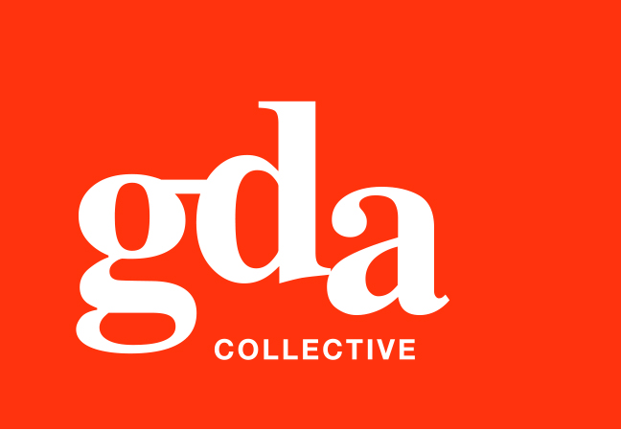
UEN: T20LL0431K

GDA Collective LLP
59 Ubi Ave 1 #06-09
Bizlink Centre
Singapore 408938

www.gda.sg

Invoice
Ascott International Management Pte Ltd
Attn: Angela Lau date February 18, 2021
delivery order no. -
payment terms 30 days
our ref no. -
job no. J/F 3216

invoice no. INV-100115-21
description & value

Being cost for Project Campaign for Ascott x Monster Day Tour
Specifications: 01. To design artwork for Tentcard (A5 2pp)
02. To design artwork for Elevator Poster (A2 1pp)
03. To design artwork for Physical Voucher (3” x 7” 2pp)
04. To design artwork for Digital Lobby/In-room Display
(3840 x 2160 px, landscaped)
05. To adapt for item 4 to 768 x 1366px Portrait
06. To design offer page promotional image
1280 x 470 px (master design)
07. To adapt for item 6 to 750 x 490px
08. To adapt for item 6 to 375 x 245px
09. To adapt for item 6 to 594 x 396px
10. To adapt for item 6 to 675 x 440px

Works: Total Creative Fee SGD 3,500.00

Grand Total SGD 3,500.00

We thank you for your business!

Please note:
Cheque/s should be crossed and made payable to GDA Collective LLP
If there should be any queries, please inform the person-in-charge and
return this bill to us within 3 days, otherwise this bill is deemed to be accepted.
Please send cheque to: 59 Ubi Avenue 1, #06-09, Bizlink Centre, Singapore 408938

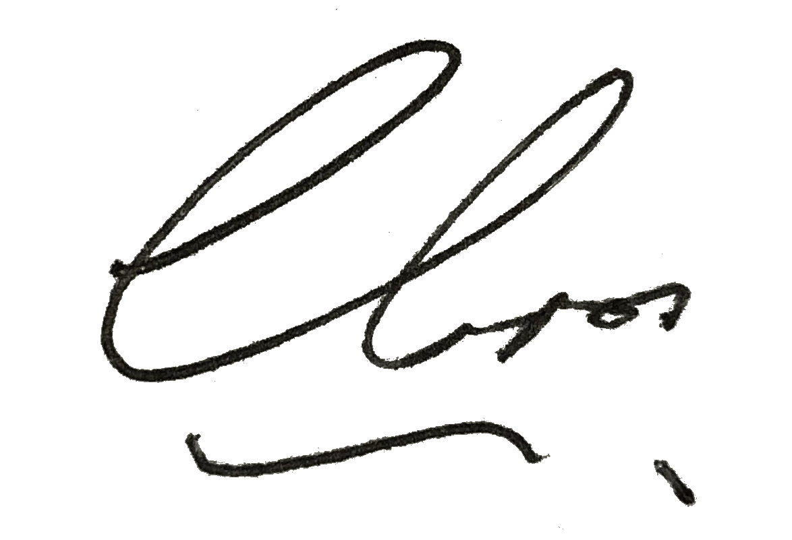
––––––––––––––––––––––––––––––––––
Authorized Signatory / GDA Collective LLP



