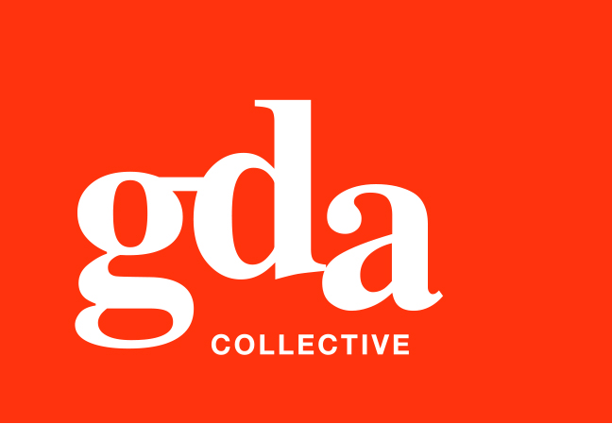
UEN: T20LL0431K

GDA Collective LLP
59 Ubi Ave 1 #06-09
Bizlink Centre
Singapore 408938

www.gda.sg

Invoice
Wilbur Investments Pte. Ltd.
60B Orchard Road, #06-18, The Atrium @ Orchard
Singapore 238891
Attn: Accounts Department date February 23, 2021
delivery order no. -
payment terms 30 days
our ref no. -
job no. J/F 3217

invoice no. INV-100116-21
description & value

Being revised cost for Connect@Changi Marketing Collaterals
Specifications: 01. 1PP Property Factsheet
02. 1PP Meeting Room Flyer
03. Corporate EDM
04. 3 x Floorplan
05. 2PP Infographic (including creating infographic drawings and icons)
06. Location Map

Works: Total Creative Fee SGD 4,990.00

Grand Total SGD 4,990.00

We thank you for your business!

Please note:
Cheque/s should be crossed and made payable to GDA Collective LLP
If there should be any queries, please inform the person-in-charge and
return this bill to us within 3 days, otherwise this bill is deemed to be accepted.
Please send cheque to: 59 Ubi Avenue 1, #06-09, Bizlink Centre, Singapore 408938

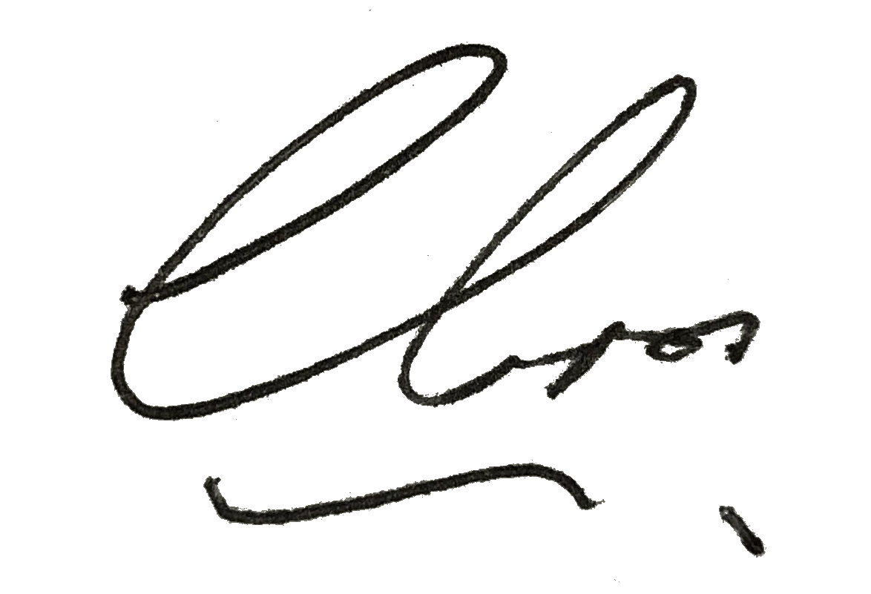
––––––––––––––––––––––––––––––––––
Authorized Signatory / GDA Collective LLP



