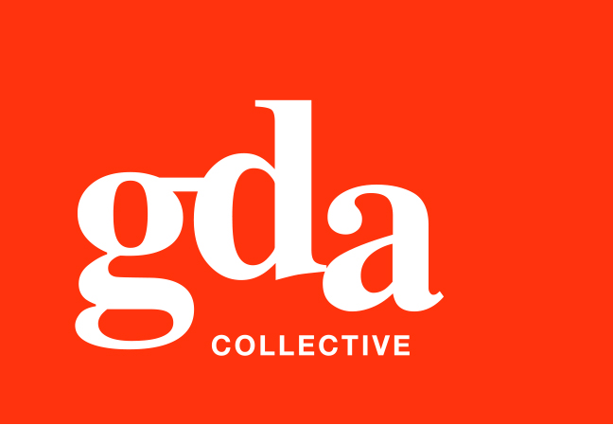
UEN: T20LL0431K

GDA Collective LLP
59 Ubi Ave 1 #06-09
Bizlink Centre
Singapore 408938

www.gda.sg

Invoice
Lesa Gan
26 East Coast Avenue date March 8, 2020
Singapore 459231 delivery order no. -
payment terms 30 days
our ref no. -
job no. -

invoice no. INV-100119-21
description & value

Being cost for various Creative services rendered

Works: DG Bannerette Design and Layout and Mock Ups and Finished Artwork SGD 300.00
We Serve With Love DG Pin Layout and Mock Ups and Finished Artwork SGD 200.00
Name Card Layout SGD 120.00
A4 Letterhead Layout SGD 120.00
DG’s Cabinet Badges SGD 120.00

PS: Kindly Take note:
Typing in of Names and designation onto
Cabinet Badges and Name Cards will be billed separately.

Grand Total SGD 860.00

We thank you for your business!

Please note:
Cheque/s should be crossed and made payable to GDA Collective LLP
If there should be any queries, please inform the person-in-charge and
return this bill to us within 3 days, otherwise this bill is deemed to be accepted.
Please send cheque to: 59 Ubi Avenue 1, #06-09, Bizlink Centre, Singapore 408938



