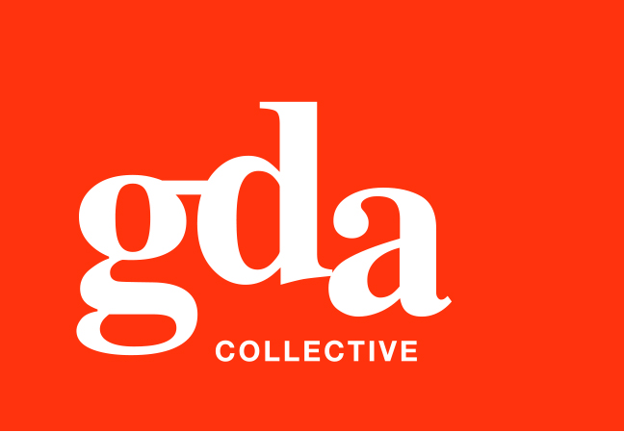
UEN: T20LL0431K

GDA Collective LLP
59 Ubi Ave 1 #06-09
Bizlink Centre
Singapore 408938

www.gda.sg

Invoice
Ascott International Management Pte Ltd
Attn: Annabelle Mak
date April 7, 2021
delivery order no. -
payment terms 30 days
our ref no. -
job no. J/F 3222

invoice no. INV-100122-21
description & value

Being cost for Ascott artwork production
Specifications: 1. Content revision to corporate sales flyer x 9 types
2. Content revision to cluster sales factsheet

Works: Production Fee SGD 500.00

Grand Total SGD 500.00

We thank you for your business!

Please note:
Cheque/s should be crossed and made payable to GDA Collective LLP
If there should be any queries, please inform the person-in-charge and
return this bill to us within 3 days, otherwise this bill is deemed to be accepted.
Please send cheque to: 59 Ubi Avenue 1, #06-09, Bizlink Centre, Singapore 408938

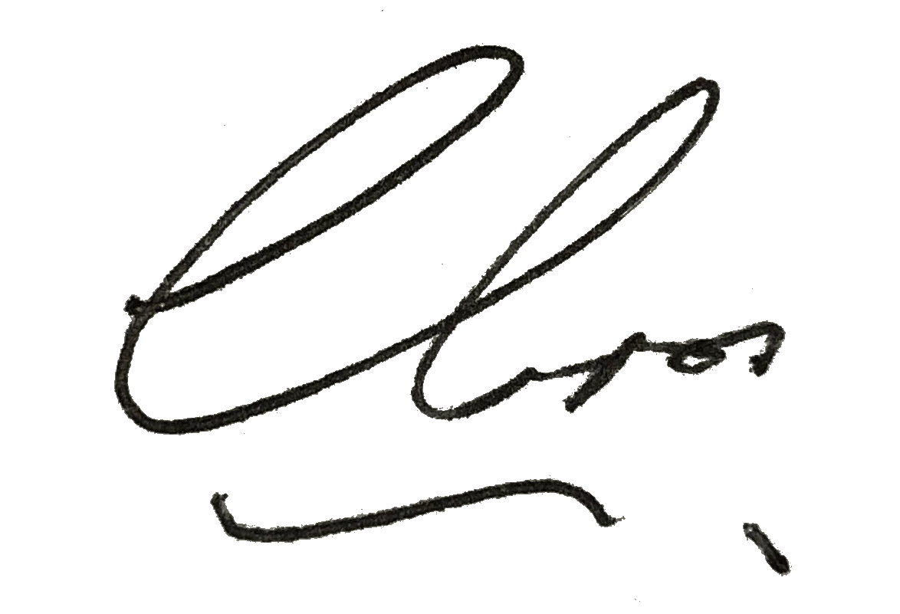
––––––––––––––––––––––––––––––––––
Authorized Signatory / GDA Collective LLP



