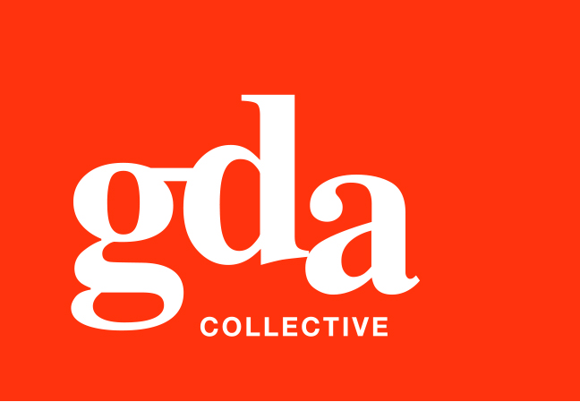
UEN: T20LL0431K

GDA Collective LLP
59 Ubi Ave 1 #06-09
Bizlink Centre
Singapore 408938

www.gda.sg

Invoice
Ikura Haus Pte Ltd
301 Upper Thomson Road date April 13, 2021
#01-57 Singapore 574408 delivery order no. -
Attn: Charlene Tan payment terms 30 days
our ref no. -
job no. J/F 3223

invoice no. INV-100123-21
description & value

Being cost for rebranding works for Wine Mansion
Specifications: 1. Wine Mansion logo design
2. Food menu design
3. Standard wine menu design
4. Premium wine menu design

Works: Project Fee SGD 5,000.00

Grand Total SGD 5,000.00

We thank you for your business!

Please note:
Cheque/s should be crossed and made payable to GDA Collective LLP
If there should be any queries, please inform the person-in-charge and
return this bill to us within 3 days, otherwise this bill is deemed to be accepted.
Please send cheque to: 59 Ubi Avenue 1, #06-09, Bizlink Centre, Singapore 408938

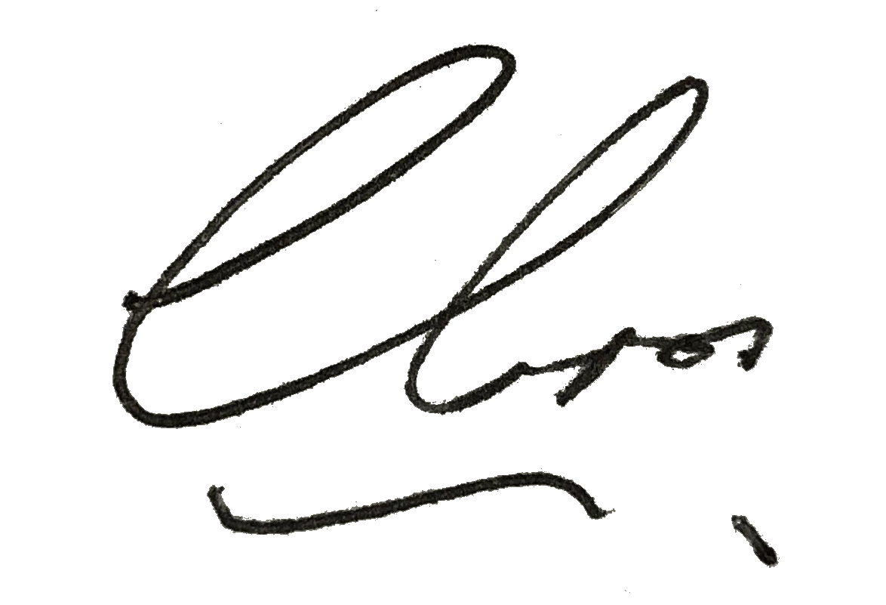
––––––––––––––––––––––––––––––––––
Authorized Signatory / GDA Collective LLP



