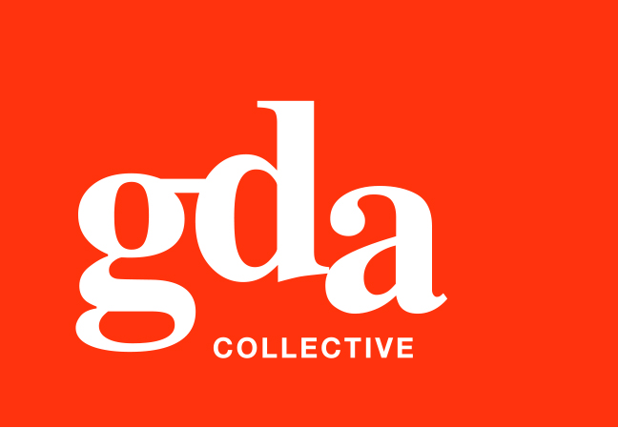
UEN: T20LL0431K

GDA Collective LLP
59 Ubi Ave 1 #06-09
Bizlink Centre
Singapore 408938

www.gda.sg

Invoice
First Media Supplies Pte Ltd
Blk 16 Kallang Place, #01-04 date April 16, 2021
Singapore 339156 delivery order no. -
Attn: Vincent Yu payment terms 30 days
our ref no. -
job no. J/F 3224/1

invoice no. INV-100124-21
description & value

Being cost for rebranding works for Wine Mansion
Specifications: 1. Website design of landing page
2. Copywriting/copyediting work
3. Overall website restructuring consultation
4. Project management

Works: Project Fee (50% deposit of $5,000) SGD 2,500.00

Grand Total SGD 2,500.00

We thank you for your business!

Please note:
Cheque/s should be crossed and made payable to GDA Collective LLP
If there should be any queries, please inform the person-in-charge and
return this bill to us within 3 days, otherwise this bill is deemed to be accepted.
Please send cheque to: 59 Ubi Avenue 1, #06-09, Bizlink Centre, Singapore 408938

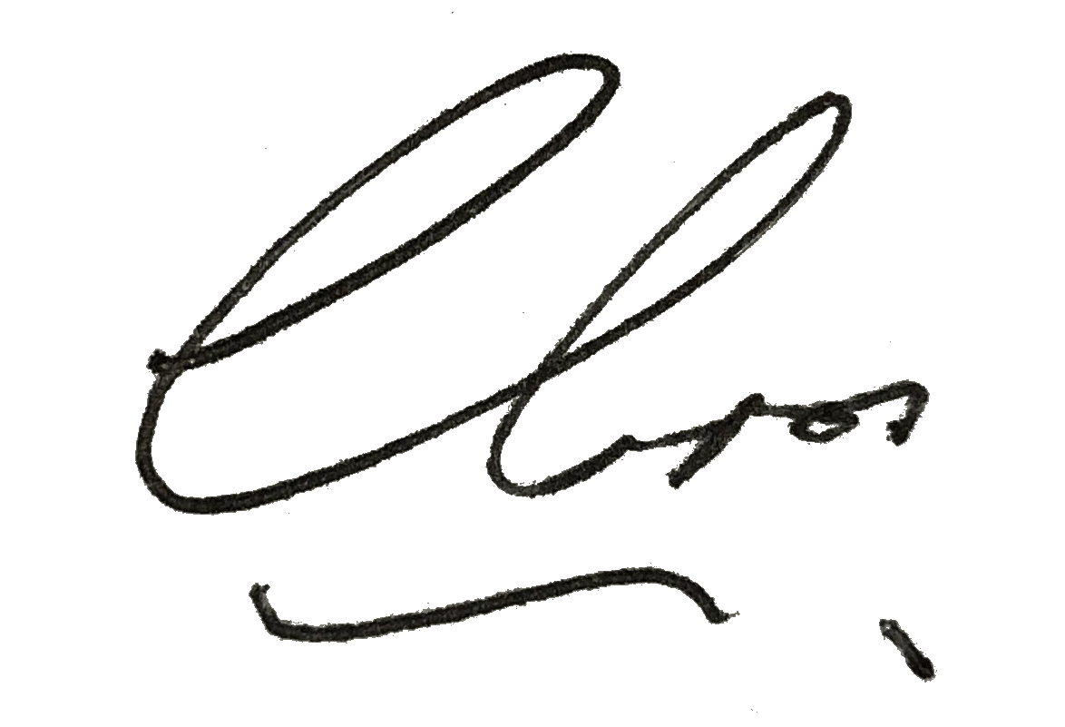
––––––––––––––––––––––––––––––––––
Authorized Signatory / GDA Collective LLP



