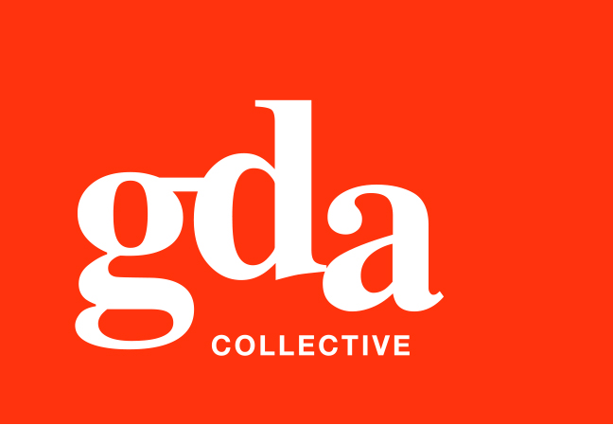
UEN: T20LL0431K

GDA Collective LLP
59 Ubi Ave 1 #06-09
Bizlink Centre
Singapore 408938

www.gda.sg

Invoice
Advanced Auto Werkz Pte Ltd
176 Sin Ming Drive date Sept 21, 2020
#01-09 Sin Ming Autocare delivery order no. -
Singapore 575721 payment terms 15 Days
our ref no. -
Attn: Peter Tan job no. -

invoice no. INV-100142-21
description & value

Being cost for Logo Revamp of Advanced Auto Werkz

Works: Logo Design and Finished Artwork
With colour specifications SGD 800.00

Grand Total SGD 800.00

We thank you for your business!

Please note:
Cheque/s should be crossed and made payable to GDA Collective LLP
If there should be any queries, please inform the person-in-charge and
return this bill to us within 3 days, otherwise this bill is deemed to be accepted.
Please send cheque to: 59 Ubi Avenue 1, #06-09, Bizlink Centre, Singapore 408938

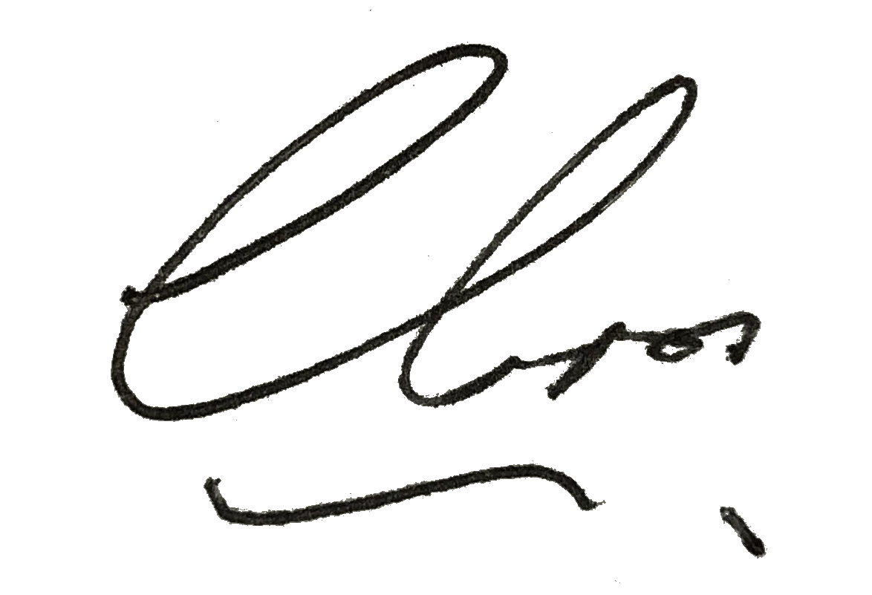
––––––––––––––––––––––––––––––––––
Authorized Signatory / GDA Collective LLP



